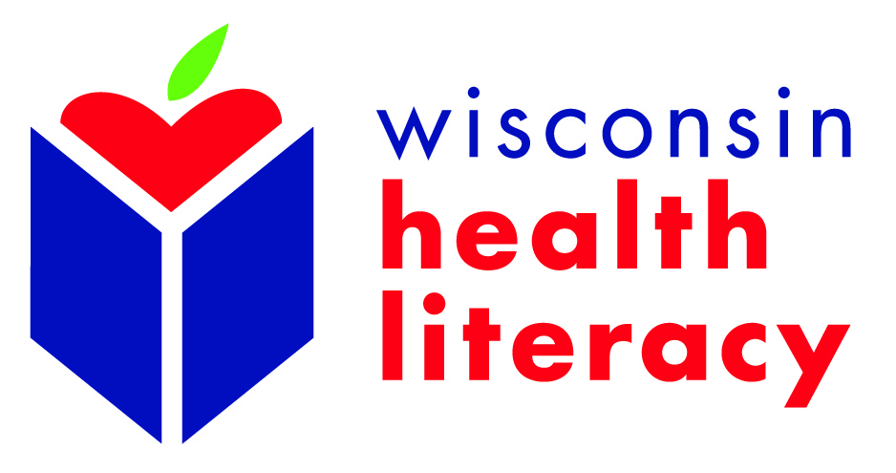

2015 Wisconsin Health Literacy Summit
Breakout Session/Poster Presenter - Request for Proposal

The 2015 Wisconsin Health Literacy Summit: Better Health through Better Communication, will be held April 14-15, 2015, in Madison, Wisconsin. We are inviting individuals to submit proposals for 60-minute breakout sessions and/or poster presentations.

Priority will be given to proposals which demonstrate how improved health communication can lead to better outcomes. This is increasingly important in the changing health care environment in which reimbursement is more closely tied to results and population health must be better managed. This includes:

- How health literate communications can help people get well or stay healthy
- Reducing health literacy barriers for those with chronic disease
- Integrating health literacy into health prevention or oral health initiatives
- Use of health literacy strategies to reduce the need for inpatient and outpatient care
- Assisting consumers in accessing, understanding and using health insurance
- Integrating health literacy practices and/or programs into adult literacy curricula
- Cultural competency and including populations served in designing, implementing and evaluating health information
- Measuring and evaluating the impact of health literacy interventions

Other relevant and timely topics will also be considered.
To apply to present a breakout session or poster presentation, complete and submit the following application by Wednesday, December 31, 2014 to: healthliteracy@wisconsinliteracy.org. Final selections will be made by the Summit Planning Committee. Session presenters will be notified of their selection by January 22, 2015. Breakout session and poster presenters must register for the Summit and may take advantage of the reduced presenter rate of $150.

For any questions, please contact:
Steve Sparks
Health Literacy Director
steve@wisconsinliteracy.org.
608-661-0207

Summit Presentation Proposal

I am applying to present:
☐ 60-minute Breakout Session
☐ Poster Presentation

Presentation Title:

Lead Presenter Description:
(Name, title, organization, maximum 100-word biography, education, including institution, major area of study, degree, year awarded. Attach CV/resume (PDF or Word document only).

Lead Presenter Contact information:
(Include mailing address, email, work phone, mobile phone)

Co-presenters (if any):
(Include name, title, organization, email address, phone for each)

Abstract/Proposal Description:
(300 word limit)

Brief Summary Description for Conference Program
(30-word limit; does not need to be in complete sentences)
- Examples:
  - Improving the health care system through partnerships between adult literacy and the health care community. Assessing needs and readiness for change.
  - Evaluating readability and suitability of patient education materials and the use of evidence-based document evaluation tools.
  - Use of the “Teach-Back” Method as a strategy to improve communication and prevent medical errors for hospitalized children and their families.

Intended Primary Audience (select only one):
☐ Health care providers (physicians, nurses, and other clinical staff)
☐ Health system administrators
☐ Health insurers
☐ Health educators or communicators
☐ Pharmacists
☐ Adult literacy providers
☐ Public health professionals & policymakers
☐ Academic researchers
☐ Other (please specify)_____________________________

Intended Secondary Audience (select only one):
☐ Health care providers (physicians, nurses, and other clinical staff)
☐ Health system administrators
☐ Health insurers
☐ Health educators or communicators
☐ Pharmacists
☐ Adult literacy providers
☐ Public health professionals and/or policymakers
☐ Academic researchers
☐ Other (please specify)_________________
☐ This presentation does not apply to any secondary audiences

Teaching Methods Used (Workshops only--check all that apply)
☐Lecture
☐Skill building exercise
☐Small or large group discussion
☐Other (please specify)____________________________

Three Learning objectives (complete below):

Learning Objective 1:
Participant will be able to…
Learning Objective 2:
Participant will be able to…

Learning Objective 3:
Participant will be able to…

Authorization for Recordings
(Read and provide written and/or electronic signature below)

Authorization consent: I consent to allowing images, words and/or video recordings of my presentation to be used by Wisconsin Health Literacy for promotional purposes.

Signed: ____________________________________________________________

Person Completing Form (if completed by someone other than Lead Presenter)
(Provide name and contact information.)

