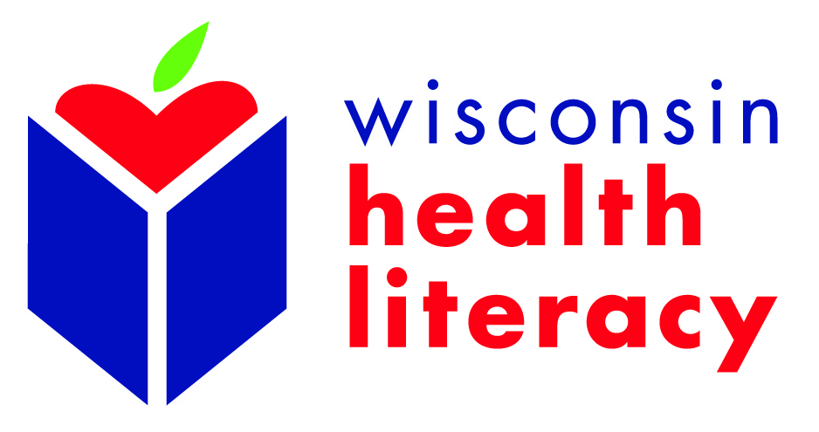

2015 Wisconsin Health Literacy Summit: Better Health Through Better Communication
April 14 and 15, 2015
Monona Terrace Convention Center

Request for Exhibit Space

Name of Company/Agency:___________________________________Phone:__________________________

Contact Person:__________________________Fax:________________Email:__________________________

This exhibit is covered through our sponsorship of the Summit (Gold: $5000) & above:
___Yes ___ No
Description of materials to be exhibited (no sales allowed): ____________________________________________________________________________________________________________________________________________________________________________________

Exhibitor space for the Wisconsin Health Literacy Summit is limited. Please apply early.

Arrangements: All exhibitors must reserve a minimum of one display table. The following is included in the costs listed below:

- Summit registration for one member of your organization or business
- 8 foot exhibit table and two chairs
- Electrical hook-up (if needed)
We require electricity: ____Yes ____No
- Table skirt (if needed)
We require a table skirt: ____Yes ____No

All-inclusive cost for the above:
$350
$250 for Wisconsin Literacy member organizations and Silver ($3000) or Friend ($1000) Sponsors

Additional Costs:
$150 for each additional person from your business or organization who attends (equal to the reduced registration fee)

$100 for each additional display table

There is a charge for the use of hard-wired or wireless Internet at the Monona Terrace and Convention Center. Please visit its website for further details: http://www.mononaterrace.com/. If needed, you may make arrangements and pay Monona Terrace directly.

* To enhance your experience at the Summit, please be sure to have your exhibit staffed during breaks and mealtimes.

Please keep a copy and return this request form, with payment, by Friday, March 6, 2015.

Make Checks Payable to:
Wisconsin Literacy, Inc.
211 S. Paterson St., Suite #260
Madison, WI 53703

Thank you for your participation in the 2015 Biennial Wisconsin Health Literacy Summit!

