Cleaning Images for Warm Up (talk about pictures to activate prior knowledge)
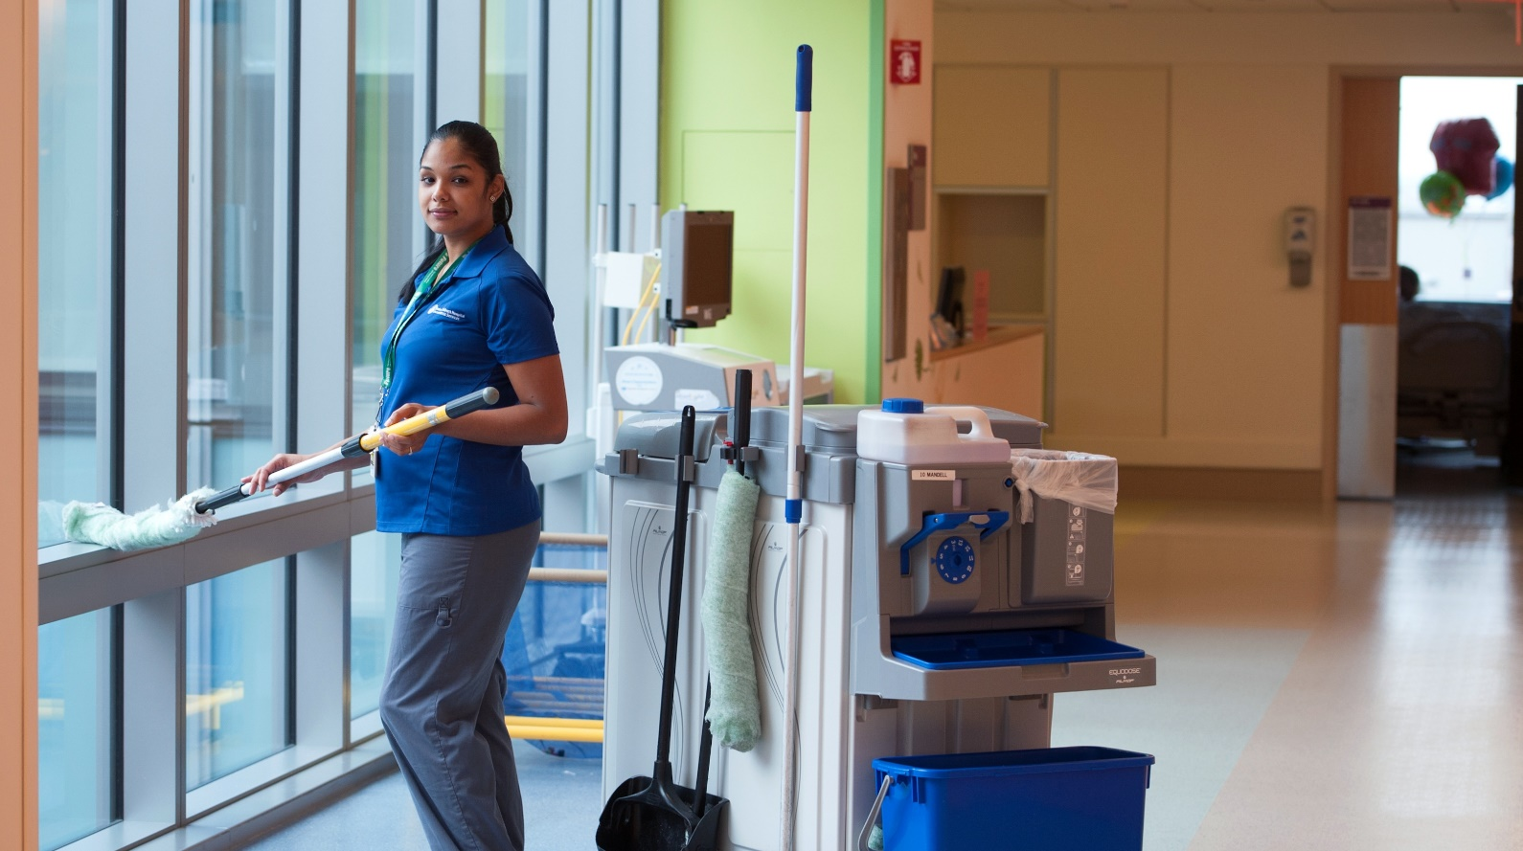
Flashcards to Introduce and Practice Vocabulary

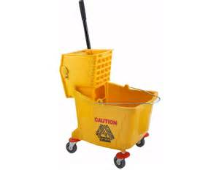
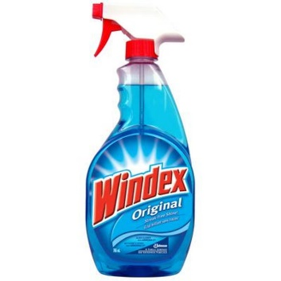
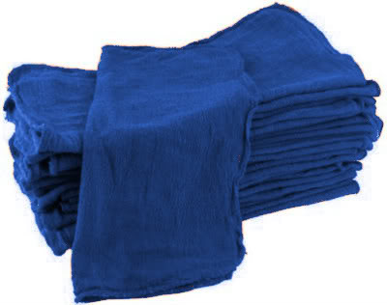
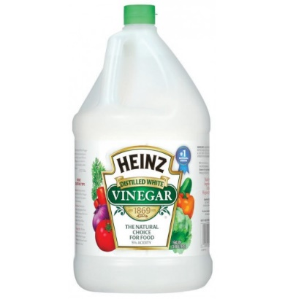

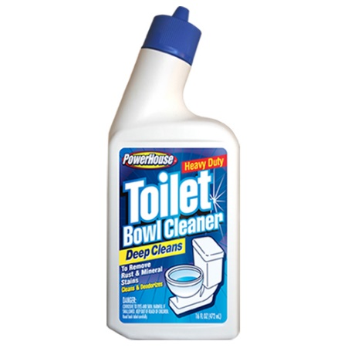
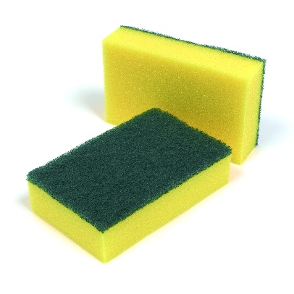
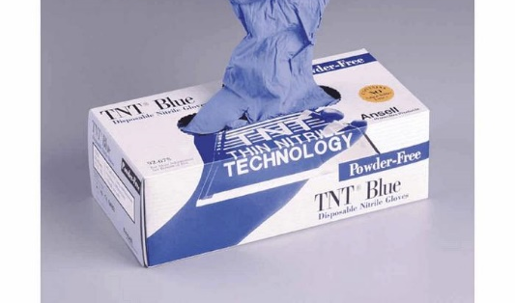
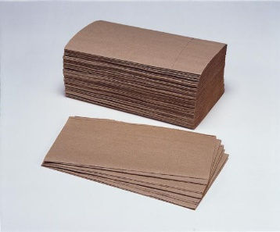

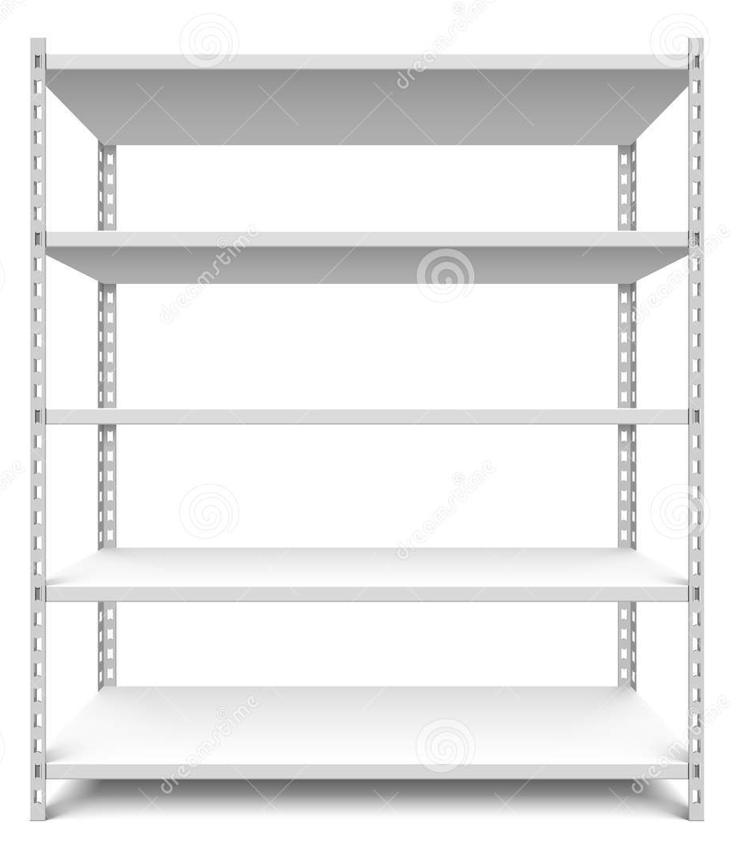
Supply Shelf to Practice Location of Supplies (put supply flashcards on supply shelf to practice asking for and describing the location of supplies)
Sample Dialogs and Cloze Activities (Levels A, B, C)
Level A
Liz: Hi Beth, can you please help me? I’m looking for extra rags.
Beth: Sure! The rags are next to the Windex.
Liz: Ok. Where is the Windex?
Beth: The Windex is always between the rags and the clean brushes.
Liz: Great. Just one more question. Where are the clean brushes?
Beth: The clean brushes are in the supply closet, on the bottom shelf.
Liz: So the rags are in the supply closet, on the bottom shelf, next to the Windex. Is that correct?
Beth: You got it.
Liz: Thanks for your help.
---------------------------------------- fold -----------------------------------------------
A
Listen to the conversation. Write the missing words.

Liz: Hi Beth, can you please help me? I’m looking for extra rags.
Beth: Sure! The rags ______________ next to the Windex.
Liz: Ok. Where _____________ the Windex?
Beth: The Windex ____________ always between the rags and the clean brushes.
Liz: Great. Just one more question. Where _________________ the clean brushes?
Beth: The clean brushes __________________ in the supply closet, on the bottom shelf.
Liz: So the rags ________________ in the supply closet, on the bottom shelf, next to the Windex. Is that correct?
Beth: You got it.
Liz: Thanks for your help.
Level B
Liz: Hi Beth, can you please help me? I’m looking for extra rags.
Beth: Sure! The rags are next to the Windex.
Liz: Ok. Where is the Windex?
Beth: The Windex is always between the rags and the clean brushes.
Liz: Great. Just one more question. Where are the clean brushes?
Beth: The clean brushes are in the supply closet, on the bottom shelf.
Liz: So the rags are in the supply closet, on the bottom shelf, next to the Windex. Is that correct?
Beth: You got it.
Liz: Thanks for your help.

---------------------------------------- fold -----------------------------------------------
B
Listen to the conversation. Write the missing words.

Liz: Hi Beth, can you please help me? I’m looking for extra ________________.
Beth: Sure! The rags ______________ next to the ____________________.
Liz: Ok. Where _____________ the Windex?
Beth: The Windex ____________ always between the _____________ and the clean brushes.
Liz: Great. Just one more question. Where _________________ the clean ______________________?
Beth: The clean brushes __________________ in the _______________ closet, on the bottom shelf.
Liz: So the ______________ ________________ in the supply closet, on the bottom shelf, next to the _____________. Is that correct?
Beth: You got it.
Liz: Thanks for your help.
Level C
Liz: Hi Beth, can you please help me? I’m looking for extra rags.
Beth: Sure! The rags are next to the Windex.
Liz: Ok. Where is the Windex?
Beth: The Windex is always between the rags and the clean brushes.
Liz: Great. Just one more question. Where are the clean brushes?
Beth: The clean brushes are in the supply closet, on the bottom shelf.
Liz: So the rags are in the supply closet, on the bottom shelf, next to the Windex. Is that correct?
Beth: You got it.
Liz: Thanks for your help.

---------------------------------------- fold -----------------------------------------------
C
Listen to the conversation. Write the missing words.

Liz: Hi Beth, can you please help me? _______________________________________________________
Beth: Sure! _______________________________________________________________________________
Liz: Ok. ___________________________________________________________?
Beth: __________________________________________always between the rags and the clean brushes.
Liz: Great. Just one more question. ________________________________________________________?
Beth: __________________________________________________________________, on the bottom shelf.
Liz: So _______________________________________________________________, on the bottom shelf, next to the _____________. Is that correct?
Beth: ________________________________________________________.
Liz: ________________________________________________________.
Dialog and Role Play Activities (use supply flashcards and image of supply shelves to provide scenario)

Look at the picture of the supply closet. Finish the conversations.
Conversation #1
Coworker: Hey there. Can you please help me? I’m looking for a mop bucket.
You: ______________________________________________________________________________
Coworker: Thanks. One more question-- where are the extra paper towels?
You: ______________________________________________________________________________
Coworker: Thanks for your help!

Conversation #2
Coworker: Hey there. Can you please tell me where the Windex is?
You: ______________________________________________________________________________
Coworker: Thanks. One more question-- where are the sponges?
You: ______________________________________________________________________________
Coworker: Thanks much!
Role Play
Look at the picture of the supply closet. Your tutor will start a conversation with you, to ask you where supplies are located. Answer your tutor’s questions.
For more practice, begin a second conversation with your tutor. Ask your tutor where supplies are located.

