**Workforce Development Boards**

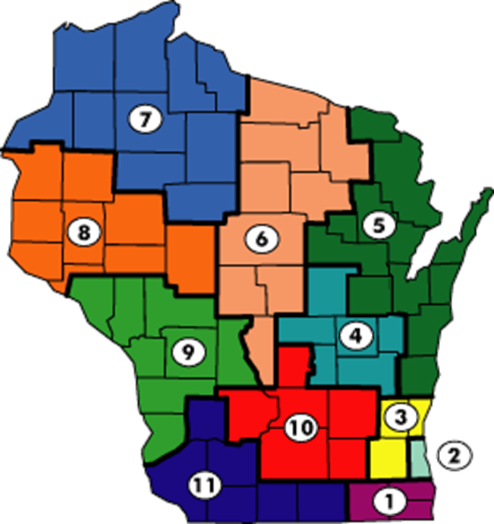

Source: dwd.wisconsin.gov/dislocatedworker/wda/wda_map.htm

|  |  |
| --- | --- |
| **WDA 1**  **Southeast Wisconsin Workforce Development Board**  **Counties:** Kenosha, Racine, Walworth  **Southeast Wisconsin WDB:** 8600 Sheridan Road, Suite 100  Kenosha, WI 53143-6507 Phone (262) 957-6760  [http://www.kenoshacounty.org](http://www.kenoshacounty.org/Archive.aspx?AMID=98) | **WDA 2**  **Employ Milwaukee**  **County:** Milwaukee  **Milwaukee Area WDB:** 2338 North 27th Street Milwaukee, WI 53210 Phone (414) 270-1709  [www.employmilwaukee.org](http://www.employmilwaukee.org) |
| **WDA 3**  **WOW Workforce Development Board**  **Counties:** Washington, Ozaukee, Waukesha  **Waukesha-Ozaukee-Washington WDB:** 892 Main Street, Suite A Pewaukee, WI 53072 Phone (262) 695-7800  <http://www.wowwdb.org/> | **WDA 4**  **Fox Valley Workforce Development Board**  **Counties:** Calumet, Fond du Lac, Green Lake, Waupaca, Waushara, Winnebago  **Fox Valley WDB:** 1401 McMahon Drive Neenah, WI 54956 Phone (920) 720-5600  <http://www.foxvalleywork.org/> |

|  |  |
| --- | --- |
| **WDA 5**  **Bay Area WDB**  **Counties:** Brown, Door, Florence, Kewaunee, Manitowoc, Marinette, Menominee, Oconto, Outagamie, Shawano, Sheboygan  **Bay Area WDB:** 317 West Walnut Street Green Bay, WI 54303 Phone (920) 431-4100  [www.bayareawdb.org](http://www.bayareawdb.org) | **WDA 6**  **North Central Wisconsin WDB**  **Counties:** Adams, Forest, Langlade, Lincoln, Marathon, Oneida, Portage, Vilas, Wood  **North Central Wisconsin WDB:** 2811 8th Street S, Suite 30 Wisconsin Rapids, 54475 Phone (715) 422-4716  [www.ncwwdb.org](http://www.ncwwdb.org) |
| **WDA 7**  **Northwest Wisconsin Workforce Investment Board**  **Counties:** Ashland, Bayfield, Burnett, Douglas, Iron, Price, Rusk, Sawyer, Taylor, Washburn  **Northwest Wisconsin WDB:** 422 Third St. West, Suite 200 Ashland, WI 54806 Phone (715) 682-9141  [www.nwwib.com](http://www.nwwib.com) | **WDA 8**  **West Central WDB**  **Counties:** Barron, Chippewa, Clark, Dunn, Eau Claire, Pepin, Pierce, Polk, St. Croix  **West Central Wisconsin WDB:** 401 Technology Drive East, Suite 100 Menomonie, WI 54751-2383 Phone (715) 235-8393 [www.wdbwcw.org](http://www.wdbwcw.org/) |
| **WDA 9**  **Western Wisconsin WDB**  **Counties:** Buffalo, Crawford, Jackson, Juneau,  La Crosse, Monroe, Trempealeau, Vernon  **Western Wisconsin WDB:** 2516 East Avenue South, Suite 101 La Crosse, WI 54601 (608) 789-5499  [www.westernwdb.org](http://www.westernwdb.org) | **WDA 10**  **WDB of South Central Wisconsin**  **Counties:** Columbia, Dane, Dodge, Jefferson, Marquette, Sauk  **South Central Wisconsin WDB:** 3513 Anderson Street, Suite 104 Madison, WI 53704 Phone (608) 249-9001  [www.wdbscw.org](http://www.wdbscw.org) |
| **WDA 11**  **Southwest Wisconsin WDB**  **Counties:** Grant, Green, Iowa, Lafayette, Richland, and Rock  **Southwest Wisconsin WDB:** 1370 N. Water Street Platteville, WI 53818 Phone (608) 342-4220  [www.swwdb.org](http://www.swwdb.org) |  |

You can find more detailed information on each of the workforce priorities, area demographics and employment partners in the Wisconsin Literacy Members Only portal. Your log-in information is stored at WL’s main office at 608-257-1655 or email [liz@wisconsinliteracy.org](mailto:liz@wisconsinliteracy.org)