COVID-19 Vaccine Outreach
Lesson Plan Template

Before you Teach:
Remember your learners may not be able to read materials in their native language. Ask if they prefer to read information in English or their native language, or if they prefer that you read information aloud.
The translated materials may be more helpful for interpreters.
Look over Vaccine FAQs: https://www.cdc.gov/coronavirus/2019-ncov/vaccines/faq.html
Read articles about vaccination hesitancy:
- https://www.usatoday.com/story/news/2021/02/16/black-history-covid-vaccine-fears-medical-experiments/4358844001/
- https://apnews.com/article/language-migrant-workers-immigration-coronavirus-pandemic-california-4565a299c825f013ee43d07cdfa019a8
Research potential causes of government mistrust:
- Tuskegee Syphilis Study
- Sterilization in Migrant Camps
Choose activities in the lesson based on your learners’ concerns and experiences. You may want to break the lesson up over several sessions or revisit information at future sessions.
Research how to schedule a vaccine appointment in your community.
The Lesson:
COVID-19 Background
Ask:
- What have you heard about COVID-19?
- Has anyone you know gotten COVID-19?
Share DHS COVID-19 Overview:
(Remember – don’t assume your learner can read in their native language.)
- English: https://www.dhs.wisconsin.gov/publications/p02592.pdf
- Spanish: https://www.dhs.wisconsin.gov/publications/p02592s.pdf
- Hmong: https://www.dhs.wisconsin.gov/publications/p02592h.pdf
- Somali: https://www.dhs.wisconsin.gov/publications/p02592so.pdf
Ask:
- What might happen if you get COVID-19?
Potential responses:
- Miss work for 2 weeks or more
- Long term health problems
- Spread to family members who could get really sick or die
Stopping the spread of COVID-19
Ask:
- How can we stop the spread of COVID-19?
Share handouts:
- Social distancing & Masks https://www.cdc.gov/coronavirus/2019-ncov/downloads/Young_Mitigation_recommendations_and_resources_toolkit_03_HS.pdf
- Vaccines
- How they all work together to stop the spread 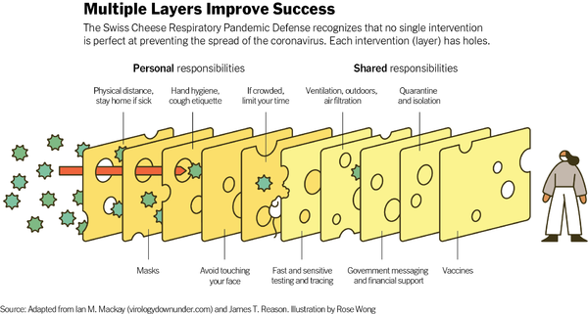

COVID-19 Vaccines
Ask:
- What have you heard about the vaccines?
(acknowledge concerns – Tuskegee, sterilization in migrant camps)
- Do you know anyone who got the vaccine? What was their experience?
Share your experience – Did you get the vaccine? What happened? When?
Share information on the vaccine that address learners’ questions and concerns about the vaccine:
(Remember – don’t assume your learner can read in their native language.)
Vaccine Safety:
- English: https://www.dhs.wisconsin.gov/publications/p02872.pdf
- Spanish: https://www.dhs.wisconsin.gov/publications/p02872s.pdf
- Hmong: https://www.dhs.wisconsin.gov/publications/p02872h.pdf
- Somali: https://www.dhs.wisconsin.gov/publications/p02872so.pdf
Video on the science and authorization of the vaccine: https://youtu.be/7bBmQaX2k4w
Share: What do you need to get a vaccine?
- Don’t need an ID. You may be asked but you don’t need it.
- Don’t need insurance. You may be asked but you don’t need it.
- What can you say if you don’t have an ID or insurance?
Share: Where do you go for the vaccine?
- Vaccines.gov
Next Steps
Ask:
- Do you want me to help you schedule an appointment now?
- We talked about a lot of information today. What will you tell your family or neighbors about the vaccine?
Record survey questions online or on paper: https://www.surveymonkey.com/r/STJ9PKM

