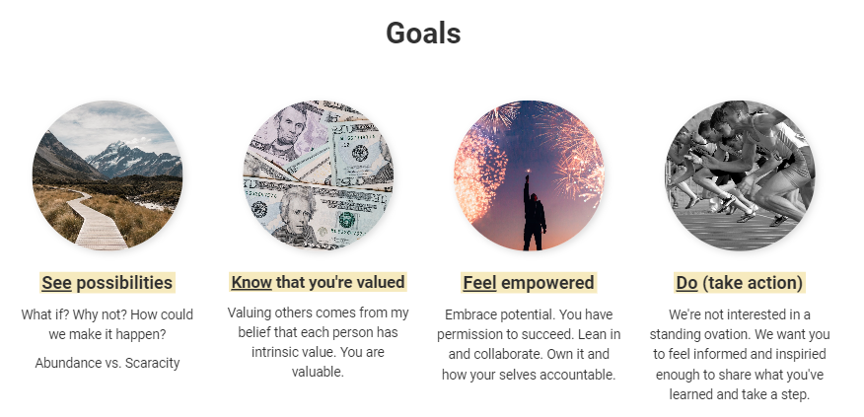

“Align your _________ with your _________ to get the _________ _________.”

– Lyle Wells, #67, The Impact of Leadership Podcast

1. I believe the WI Literacy staff, the Regional Literacy staff & WI Health Literacy staff are all vital to the mission of our organization. **True or False**
2. I want the best ideas to win even if they’re not my ideas. **True or False**
3. I struggle to engage in meetings. (board/committee/own team meetings) **True or False**
4. I have a clear understanding of how my performance impacts if the mission is carried out. **True or False**
5. I believe we/I can do better. True or False
   1. If you answered True, how so? ________________________________________________________________ ________________________________________________________________

________________________________________________________________

**Courage is underpinned by vulnerability.**

What did you hear others say? Agree/Disagree? Jot down thoughts/ideas/questions.

How will you utilize this information? What are a few steps to be taken?  
_________________________ _________________________

_________________________ _________________________

_________________________ _________________________

_________________________ _________________________

_________________________ _________________________

_________________________ _________________________

