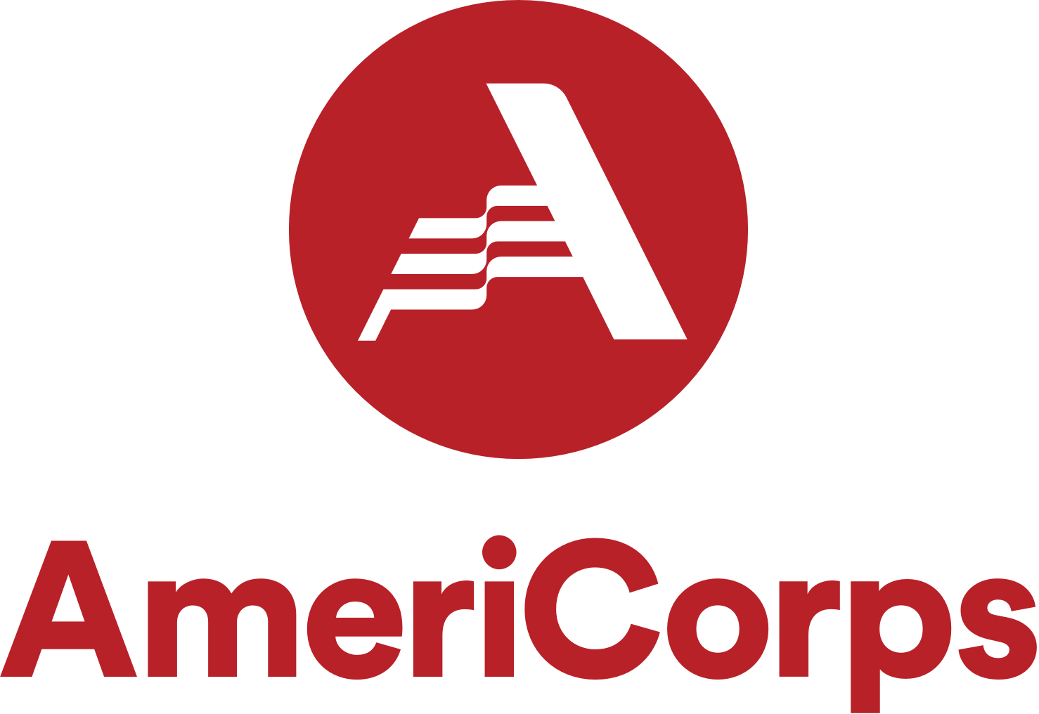

AmeriCorps VISTA Opportunity: Literacy Leader

West CAP, an innovative, forward thinking community action organization serving low-income families, is recruiting a full-time Literacy Leader in partnership with AmeriCorps VISTA.

Specific location is flexible and remote work options are available, but you must be regionally local and willing and able to conduct occasional travel throughout Polk, St. Croix, and Pierce counties in Wisconsin. You must also comply with West CAP and AmeriCorps’ COVID-19 safety policies, which mandate full vaccination or weekly testing. This position is for a one-year term beginning January 18, 2022. You will help West CAP Literacy rebuild our Adult Literacy Program to recover from the impact of COVID-19. It is time to renew our literacy program and make it better than ever!

Responsibilities include:
- Recruiting learners and volunteers in Polk, St. Croix, and Pierce counties
- Evaluating and enhancing West CAP’s existing tutor trainings through researching other available training options
- Training tutors to use Zoom or other video calling programs for distance tutoring
- Creating a learner orientation that utilizes digital technology resources

Qualifications:
- Enrolled in or graduated from an associate or bachelor’s degree program in Education, Communications, Marketing, Social Sciences or related field
- Strong computer skills and experience using Microsoft suite, online video conferencing, social media, and other platforms used for distance learning
- Ability to work with people with learning disabilities and English Language Learners
- Excellent written & oral communication skills
- Must possess valid driver’s license, have reliable transportation, and be deemed an insurable driver by our insurance provider prior to hire
- Ideal candidates will have at least basic Spanish conversational skills

If you don’t meet all of the above qualifications but still think you might be a good fit for this opportunity, please reach out or apply! We’d love to hear what you have to offer.

This position may be eligible for AmeriCorps benefits such as:
- Biweekly living allowance
- $6,345 educational award or a cash stipend
- Relocation stipend and travel allowance
- Work transportation reimbursement
- Healthcare allowance
- Many other AmeriCorps benefits, such as federal student loan forbearance and other benefits

West CAP embraces diversity, inclusion, and employees who reflect the population we serve. We encourage applications from all qualified candidates including women, minorities, veterans, and people who have disabilities. For consideration, please apply through AmeriCorps Vista at: West CAP - Digital Equity and Technology Integration (LitMN). Application is due December 15, 2021.

West CAP is an Equal Employment Opportunity organization.

